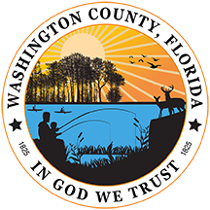
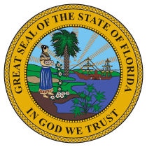
RENEA PETERS, CFA
WASHINGTON COUNTY PROPERTY APPRAISER

1331 South Blvd., Suite 300
P. O. Box 695
Chipley, FL 32428
Phone: (850) 638-6205 Website: www.washcofl.com/pa

Congratulations on the purchase of your home in Washington County! If you are making the home your primary residence, you may be eligible for a tax savings with Homestead Exemption.

What is Homestead Exemption?
State law allows Florida homeowners to claim up to a $50,000 Homestead Exemption on their primary residence.

How do I qualify?
As of January 1st, you must:
- Have recorded legal or beneficial title to the property. (This includes title to mobile homes.)
- Be a US citizen or have a Permanent Resident Card (copy required)
- Be a legal resident of Washington County with your Florida Driver’s license updated to reflect the new address.
- Maintain the property as your permanent home

When do I file?
January 1st through March 1st the year after obtaining the property.

How do I file?
You must file in person at the Washington County Property Appraiser’s office located at 1331 South Blvd, Ste 300, Chipley. When filing for Homestead Exemption you MUST provide the following at the time of application:
- Florida Driver’s License for each applicant that reflects the address of the property for which you are seeking the exemption. A copy of your spouse’s Florida Driver’s License is required even if they are not on the deed for the property.
  - If you do not drive you must provide a copy of a Florida Identification card reflecting the property address.
- If you are not a U.S. citizen, you must provide a copy of your resident alien (green) card.
- Social security numbers for all applicants, their spouse (even if spouse has no ownership interest or does not reside on property) or any occupant who may be entitled to the exemption. Social Security numbers will remain confidential pursuant to FS 193.114(6) and FS 193.074.
- Washington County Voter Registration card or number, if you are registered to vote.
- If dwelling is a manufactured home, a copy of the registration or title to the manufactured home. Title must be transferred to your name.

Are there other exemptions available?
Yes. In addition to Homestead there are exemptions available for Limited Income Seniors, Veterans, Widows/Widowers and Disability. There will be additional proof required for these exemptions. Please contact the office at 850-638-6205 for additional information.

What if my property is held in a trust?
When property is held in a trust, Florida law specifies those situations under which the resident may obtain homestead exemption. You will be asked to submit your trust documents for a review to determine if you are eligible for the exemption.

